**NAME: Samyak Chanekar**

**PRN:23070521125**

**SEC: B(B2)**

**Using ODBC (Open Database Connectivity) for Database Operations**

ODBC allows applications to interact with databases like Oracle, MySQL, SQL Server, etc., using a standardized API. Below, I'll show how to **connect to a database** and perform **basic operations** using **ODBC in Python**.

**By using PYTHON**

**Download Python**

* Go to the official Python website: <https://www.python.org/downloads/>
* Click the "Download Python" button (this will download the latest version)

**Install Required Packages**

First, install the pyodbc library (for Python):

To install above

1. Win + X, then click **Windows Terminal**
2. pip install pyodbc
3. python -c "import pyodbc; print(pyodbc.version)"

**ODBC Connection Setup**

To use ODBC, configure a **DSN (Data Source Name)** in your system:

* **Windows:** Go to Control panel → Windows tools (older versions of windows ADMINISTRATIVE TOOL)→ *ODBC Data Sources (64-bit)* → *Add* → Oracle in OraDb11g_home →
  1. Data source name : orcl.
  2. Description:
  3. Tns service name:
  4. User ID : sit2

→ click OK ( it will ask password : sit)

**Python Code for ODBC Database Operations**

The following Python program connects to a database via ODBC and performs **CRUD (Create, Read, Update, Delete)** operations.

* **Python Script Using ODBC**

import pyodbc

# Oracle DSN connection details

dsn_name = "Orcl" # Replace with your actual DSN

user = "sit2"

password = "sit"

try:

# Connect to Oracle using DSN

conn = pyodbc.connect(f"DSN={dsn_name};UID={user};PWD={password}")

# Create a cursor

cursor = conn.cursor()

# 1. Create Table

cursor.execute("Drop table acc")

cursor.execute('''

CREATE TABLE Acc (

Account_No INT PRIMARY KEY,

Holder_Name VARCHAR(100),

Balance FLOAT

)

''')

print("Table Acc created successfully.")

# 2️ Insert Data

cursor.execute("INSERT INTO Acc VALUES (101, 'Alice', 5000)")

cursor.execute("INSERT INTO Acc VALUES (102, 'Bob', 3000)")

conn.commit()

# 3️ Read Data

cursor.execute("SELECT * FROM Acc")

for row in cursor.fetchall():

print(row)

# 4️ Update Data

print("\nTable Acc before update.")

cursor.execute("SELECT * FROM Acc")

for row in cursor.fetchall():

print(row)

cursor.execute("UPDATE Acc SET Balance = Balance + 1000 WHERE Account_No = 101")

conn.commit()

print("\nTable Acc after update.")

cursor.execute("SELECT * FROM Acc")

for row in cursor.fetchall():

print(row)

# 5️ Delete Data

# cursor.execute("DELETE FROM Accounts WHERE Account_No = 102")

conn.commit()

# Close connection

cursor.close()

conn.close()

except Exception as e:

print("Error:", e)

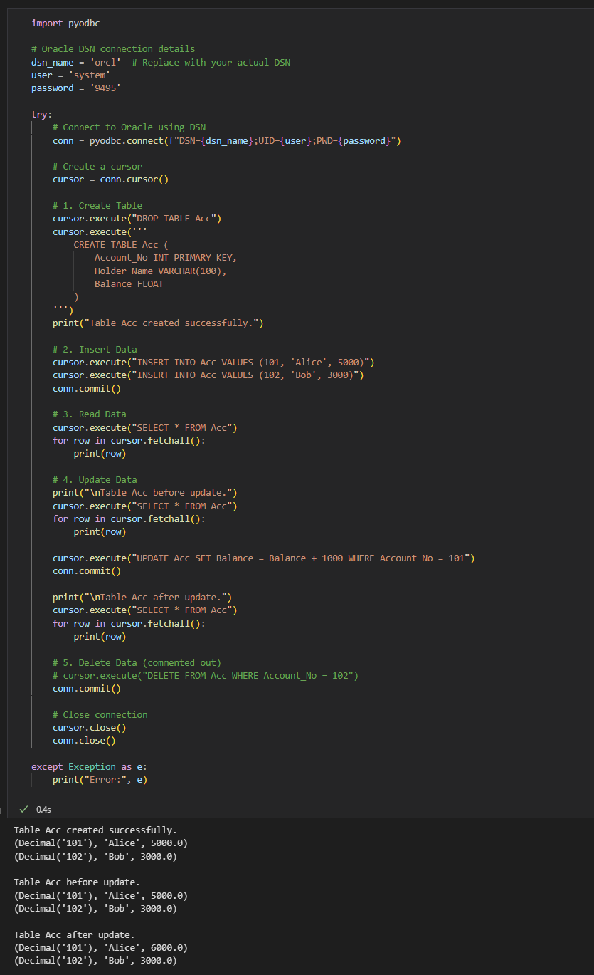

**Explanation of Operations**

1. **Connect to Database:**
   * Uses pyodbc.connect() to connect using ODBC.
   * Replace your_server_name, your_database, your_username, and your_password accordingly.
2. **Create a Table (Accounts)**
   * Defines columns: Account_No, Holder_Name, Balance.
3. **Insert Records**
   * Adds sample data (Alice and Bob).
4. **Retrieve Records**
   * Fetches all records and prints them.
5. **Update a Record**
   * Increases Alice's balance by 1000.
6. **Close Connection**
   * Closes the database connection to free resources.